# Booking Module

Booking Dashboard:

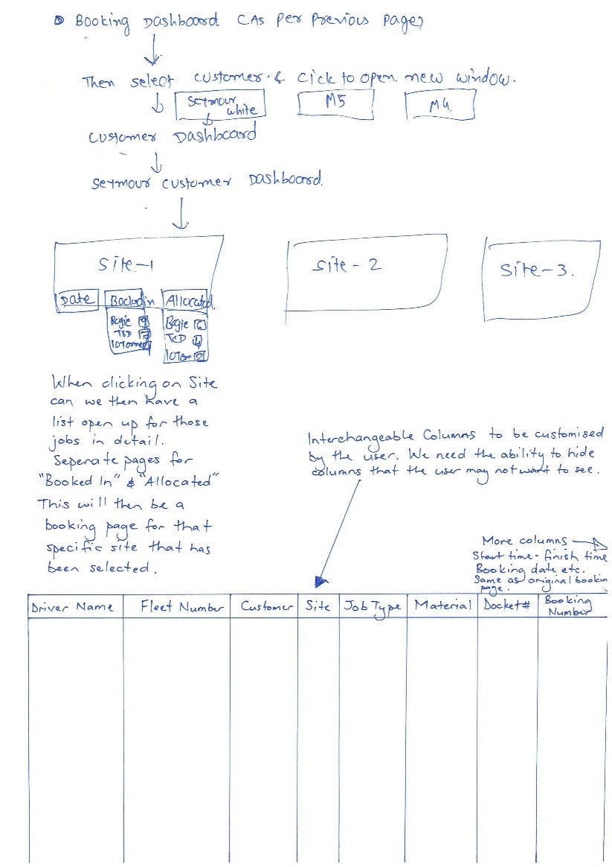

SIPL Understanding:

* We got the first 2 steps as mentioned below:
  + From booking dashboard admin will select customer
  + On new page, selected customer sites will be shown and this page will be termed as customer dashboard
* Site-1, will have below three buttons:
  + Date: Clicking on this button, a page will appear having below fields.
    - Date Picker: From Date & To Date
    - Dropdown to select fleet category
    - Textbox to enter number for fleets required for selected category
    - Book Fleets Button: Clicking on these 10 rows with selected fleet category will be created and will be shown in Booked In section

***Note:*** *There will also be a “Add More” button, clicking on it same above fields will appear. By this way admin can add multiple fleet categories.*

* + Booked In: We have to replace the below booked in table style and please change as we show on (page 1 under Booking Dashboard (Column wise (Driver Name, Fleet Number, Customer, site, Job type, Material, Docket Number, booking number, add more column as require)
    - Once admin clicks on this button new page will open, a table will be shown having list of fleets that needs to allocated.
    - On top fleet categories will be shown with respective number of fleets are in booked in state.
    - The columns will be same as currently we are having in booking form. Please check below screenshot for the same.

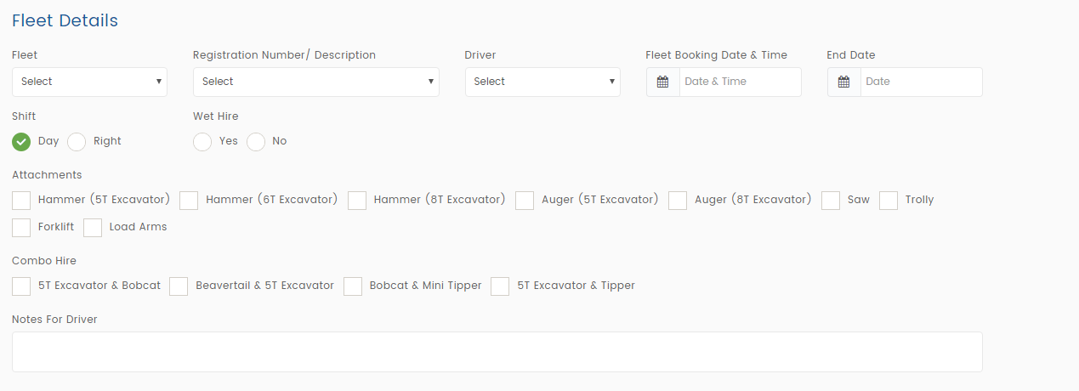

* + - There will be an option to allocate, once admin ticks on allocate then selected fleet will go into allocation section. A SMS will be sent to driver with all the details.
  + Allocated
    - Once admin clicks on this button new page will open, a table will be shown having list of fleets that needs to allocated.
    - On top fleet categories will be shown with respective number of fleets are in allocated state.

***Note:*** *For now, we will not be able to provide interchangeable columns, hide feature & right click option. Once our core features are completed then we will estimate efforts for the same and share with you. Then after your approval, will work on it.*

Allocated List of Fleets:

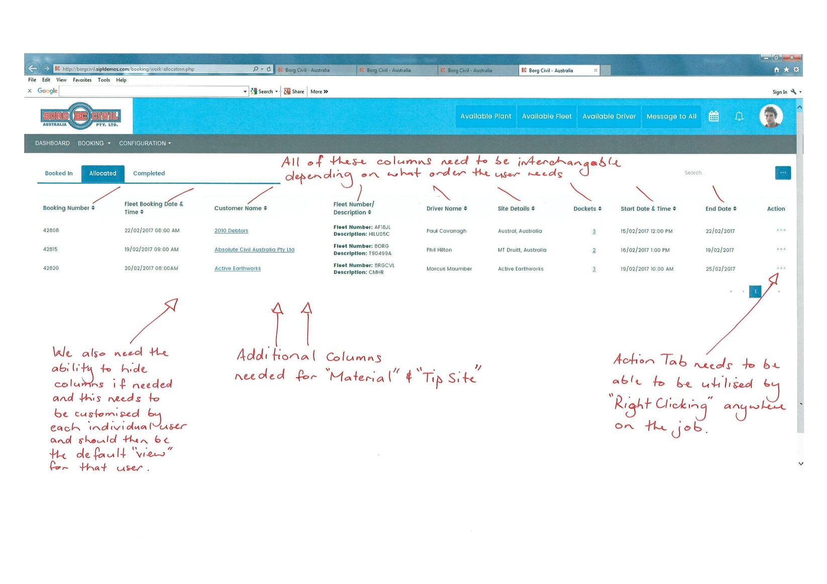

SIPL Understanding:

* Okay we will add columns – Material & Tip Site.

***Note:*** *For now, we will not be able to provide interchangeable columns and hide feature. Once our core features are completed then we will estimate efforts for the same and share with you. Then after your approval, will work on it.*

SIPL Queries:

* Please share us, where we need to add Material & Tip Site in booking form? So that we can show it here in the list.

Existing Job Booking Form (General Details):

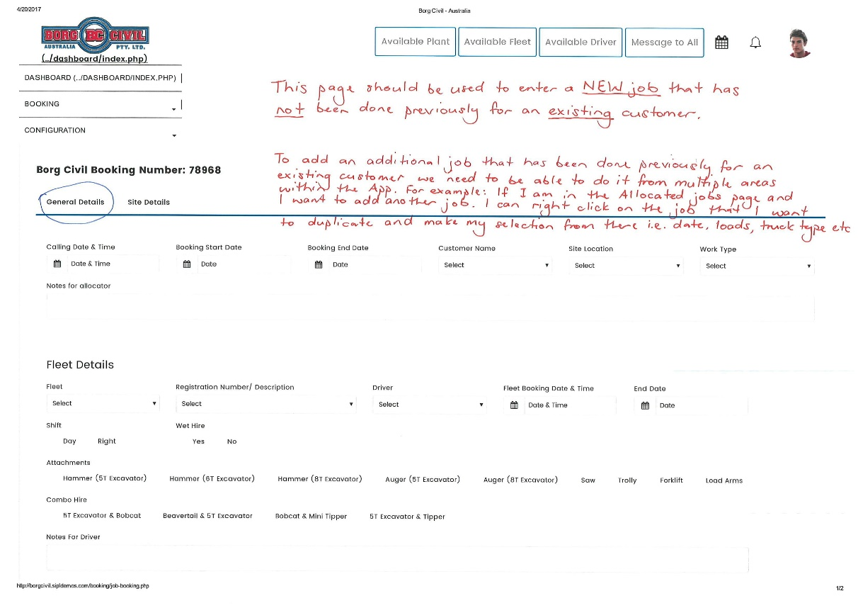

SIPL Understanding:

* Yes, we will keep this form also with the booking from customer dashboard.

SIPL Queries:

* Can you please put some more light on duplicate booking? ***So, if there is a job already booked In, allocated or even completed, we need to be able to just right click on that job and have the ability duplicate it. As in add another job exactly the same as the last.***

Existing Job Booking Form (Site Details):

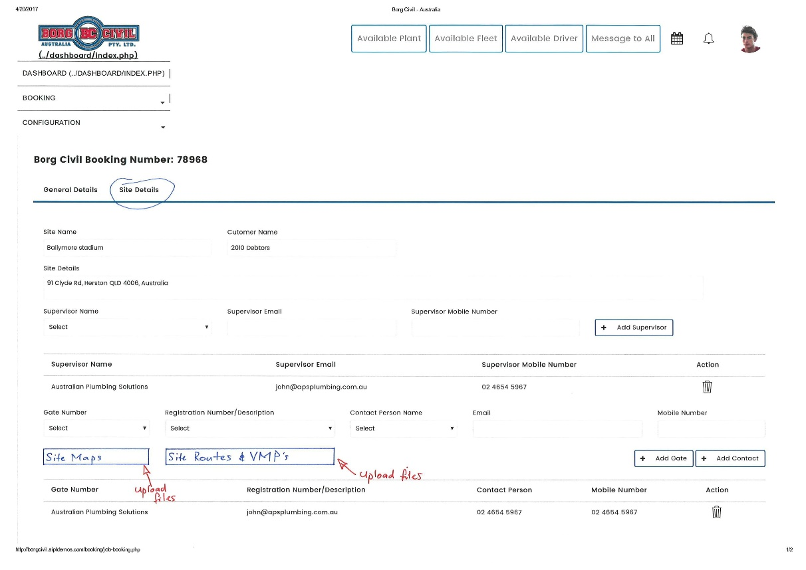

SIPL Understanding:

* Sure, we will provide option to upload Site Maps & Site Routes. (Multiple file uploader)

Work Allocation:

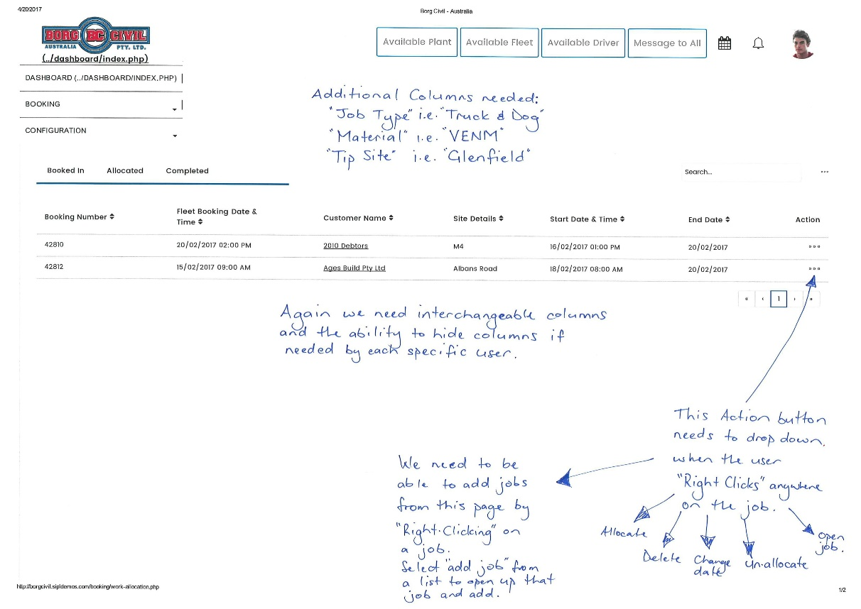

SIPL Understanding:

* Sure, we will add new columns. Please share us, where we can add Material & Tip site on job booking form.
* Clicking on Open Job, admin can add more fleets into existing job. Please let us know, if you have any different views for the same.

***Note:*** *For now, we will not be able to provide interchangeable columns and hide feature. Once our core features are completed then we will estimate efforts for the same and share with you. Then after your approval, will work on it.*

Booking List:

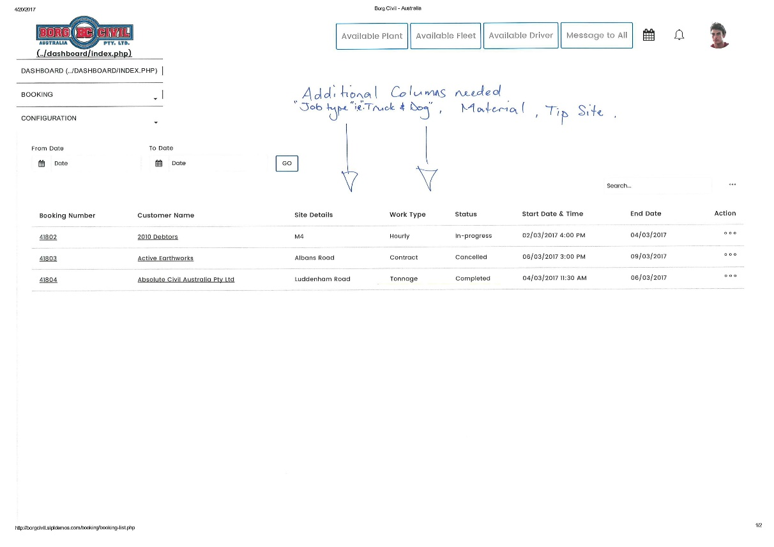

SIPL Understanding:

* Sure, we will add new columns. Please share us, where we can add Material & Tip site on job booking form.